Gap Analysis:
Promoting Safety: Alternative Approaches to the Use of Restraints, February 2012
Work Sheet

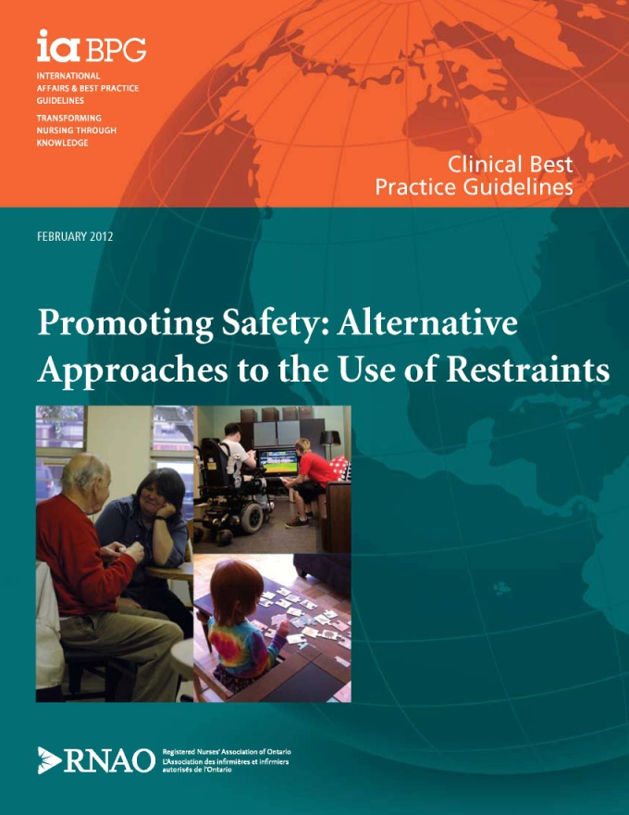
This guideline can be downloaded for free at:
http://rnao.ca/bpg/guidelines/promoting-safety-alternative-approaches-use-restraints

The RNAO Leading Change Toolkit 3rd Edition
https://rnao.ca/leading-change-toolkit

Date Completed:
Team Members participating in the Gap Analysis:
Completion of this gap analysis allows for the annual comparison of your current practice to evidence-based practices as regulated by the MOHLTC per Fixing Long-Term Care Act, 2021 at https://www.ontario.ca/laws/statute/21f39 & O. Reg. 246/22: GENERAL (ontario.ca)

RNAO Best Practice Guideline (BPG) Recommendations | Met | Partially Met | Unmet | Notes  (Examples of what to include: is this a priority to our home, information on current practice, possible overlap with other programs or partners)
Practice Recommendations
1 Nurses establish a therapeutic relationship with the client who is at risk of harm to self/others to help prevent the use of restraints.
(Level IV Evidence)
2 Nurses should assess the client on admission and on an ongoing basis to identify any risk factors that may result in the use of restraints.
(Level IIb Evidence)
3 Nurses should utilize clinical judgment and validated assessment tools to assess clients at risk for restraint use.
(Level IIb Evidence)
4 Nurses in partnership with the interprofessional team and client/family/substitute decision-makers (SDM) should create an individualized plan of care that focuses on alternative approaches to the use of restraints.
(Level IIb Evidence)
5 Nurses in partnership with the interprofessional team should continuously monitor and re-evaluate the client’s plan of care based on observation and/or concerns expressed by the client and/or family/SDM.
(Level IV Evidence)
6 Nurses in partnership with the interprofessional team should implement multicomponent strategies to prevent the use of restraints for clients identified at risk.
(Level IIa Evidence)
7 Nurses in partnership with the interprofessional team should implement de-escalation and crisis management techniques and mobilize the appropriate resources to promote safety and mitigate risk of harm for all in the presence of escalating responsive behaviours.
(Level IIb Evidence)
8 Nurses in partnership with the interprofessional team should engage in care practices that minimize any risk to the client’s safety and well-being throughout the duration of any restraining process.
(Level IV Evidence)
Education Recommendations
9 Education on working with clients at risk for the use of restraints should be included in all entry to practice nursing curricula as well as ongoing professional development opportunities with specific emphasis on:
- Approaches to care: (e.g. trauma informed care);
- Communication and education of client/family/SDM and key components of debriefing;
- Education on nursing responsibilities for the proper application of restraints;
- Ethical decision-making;
- Knowledge of diagnoses and common triggers associated with responsive behaviours putting clients at risk for the use of restraints;
- Interprofessional collaboration;
- Knowledge of basic prevention, alternative approaches, de-escalation and crisis management;
- Monitoring and documentation responsibilities;
- Nurses’ responsibilities regarding self-reflection and exploring their values and beliefs surrounding the use of restraints and threats to client autonomy and human rights;
- Therapeutic nurse client relationships; client-centred care and client rights;
- Types of restraints (least to most restrictive) and associated safety risks, and the potential complications from the use of restraints; and
- Understanding of the legal and legislative requirements governing the use of restraints.
(Level Ib Evidence)
Organization & Policy Recommendations
10 Health-care organizations should implement risk management and quality improvement strategies to enable a culture that promotes alternative approaches to the use of restraints in support of client rights and staff safety by:
- Establishing a definition of what is a restraint;
- Developing a philosophy that promotes alternative approaches to the use of restraints;
- Establishing a restraint reduction/prevention policy;
- Developing structures that allow for early identification of clients at risk of harm to self/others placing them at risk for the use of restraints;
- Educating the client/family/SDM about the associated risks of restraint use and exploring their concepts of safety;
- Establishing a multi-component program including staff education on alternative strategies to the use of restraints;
- Using alternative approaches, de-escalation and crisis management as the first and second line intervention strategies prior to the use of restraints as a safety measure of last resort;
- Establishing monitoring protocols for clients and the documentation requirements for the duration of any restraining episode;
- Establishing communication responsibilities and debriefing procedures for client/family/SDM and the interprofessional team; and
- Establishing evaluation programs to monitor the rate of restraint use, the uptake of alternative approaches to the use of restraints, and the impact on client/family/SDM and interprofessional team safety.
(Level Ib Evidence)
11 The organization’s model of care should promote an interprofessional team approach in collaboration with the client/family/SDM that supports the use of alternative approaches and prevents the use of restraints.
(Level III Evidence)
12 Nursing BPGs can be successfully implemented only where there are adequate planning, resources, organizational and administrative support, as well as appropriate facilitation. Organizations may wish to develop a plan for implementation that includes:
- An assessment of organizational readiness and barriers to education, taking into account local circumstances.
- Involvement of all members (whether in a direct or indirect supportive function) who will contribute to the implementation process.
- Ongoing opportunities for discussion and education to reinforce the importance of best practices.
- Dedication of a qualified individual to provide the support needed for the education and implementation process.
- Ongoing opportunities for discussion and education to reinforce the importance of best practices.
- Opportunities for reflection on personal and organizational experience in implementing guidelines.
(Level IV Evidence)

